FROM WHY TO HOW
volunteering project
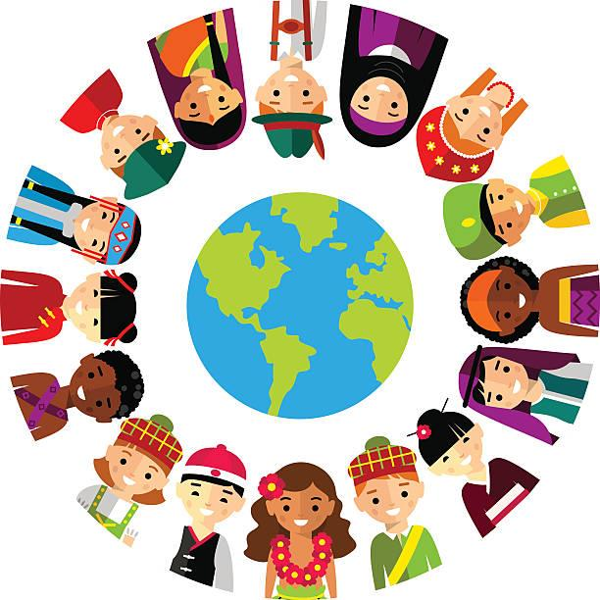

INFOPACK
GENERAL INTRO TO THE PROJECT “from why to how”
OUR ORGANISATION
Ars Viva is an institute for cultural integration and socialization of social groups. It implements various projects that help to integrate vulnerable groups into society and through its projects empowers them to operate independently.
From the very beginning, we have included local volunteers with whom we have signed volunteering statements. In 2015, however, we welcomed European volunteers into our organization, who had a major impact on the local environment, especially young people, who also became involved in the EVS program.
Over the years, we have been confronted with the problem of integrating diversity into modern society. Our projects show a high degree of positive impact on society, community.

VOLUNTEERING PROJECT in slovenia

LONG TERM ACTIVITY – 12 MONTHS
From 1th January 2020 till 31th December 2020
Volunteers from Spain, France, Kosovo…different countries
3 volunteers

Volunteers are registered in the ECS Portal, the age limit is determined by the program itself and
wanted profile is:
- a high degree of openness for difference,
- motivation to work with vulnerable groups and motivation for learning different skills,
- interest in the social and tourism sector.

Main activities of volunteers:
1. Helping to integrate immigrants into society - getting acquainted with various programs that work
in the field of integration of migrants.
2. Acquaintance with our projects at the headquarters of our organisation and assisting in their
implementation and getting acquaintance with accessible tourism (operation of the hostel and
additional tourist offers) and working with vulnerable groups. By doing this they will gain
competences that will help them increase their employability.

Their tasks:
1. In Postojna - making their workshops (creative workshops, discussion groups, conducting foreign
Courses language, culinary workshops and etc.) in programs where immigrants are already included:
- Daily Center for children and adolescents - carrying out workshops with children of migrants and
other children - DC users,
- PUM-O (Project learning for young adults) - making their workshops, which they prepare with help
of the mentor, with the aim of involving Kosovo migrants and young immigrants from Third World
countries.
- Šent - making their workshops for Kosovo women and children, giving learning help both in Šent
and in the Postojna Youth Center.

Their work is not directed at the headquarters of the organisation, but at the location of organisations
where we can find immigrants in our local community. They focus is on immigrants and not on the
organisation

2. In Podcerkvi:
- getting acquainted with current projects of our organisation,
- assistance in organising events, conducting own events,
- provide unhindered tourist offer with our team.

3. Prepare a presentation of ESC programs and programs together with vulnerable groups, in both
cities and beyond, and present them to other organisations in the region, secondary and elementary
schools, and intergenerational centers.

4. Cooperation with local volunteers. Especially with Popal Zai - migrants from Afghanistan, Ojalan
Olotsman - a migrant from Syria who will helped them to get in touch with this kind of immigrants and helped volunteers to properly conduct workshops. They will jointly indicate the way they work with immigrants and write down the guidelines that helped them establish contact.

Volunteer will sign activity agreement where all responsibilites and rights will be listed.
AVANUE of volunteering service
POSTOJNA
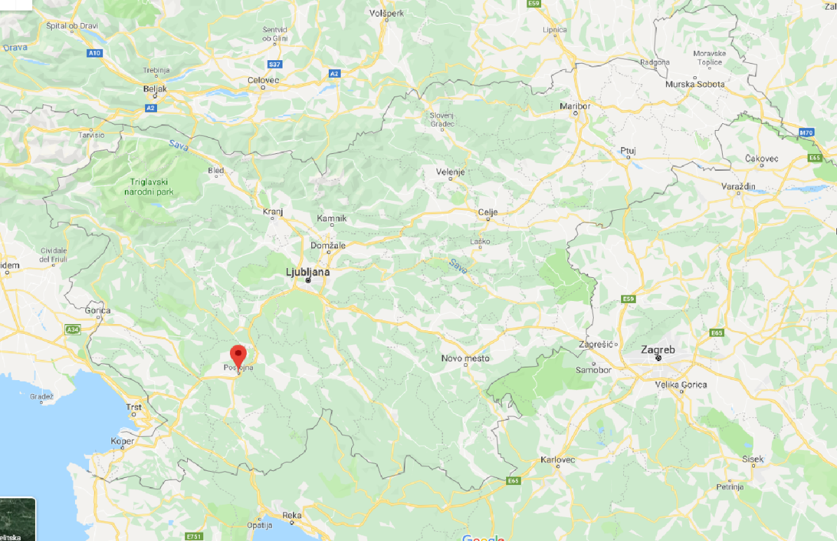
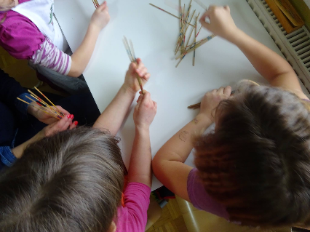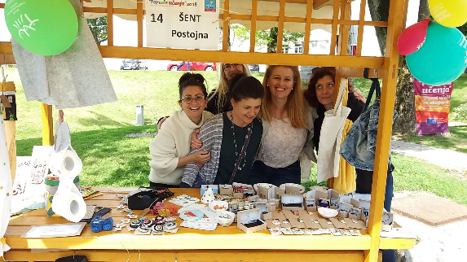
Daily Center for children Šent Postojna

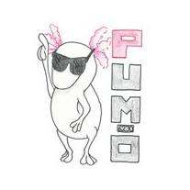
Project learning for younger adults
PODCERKEV
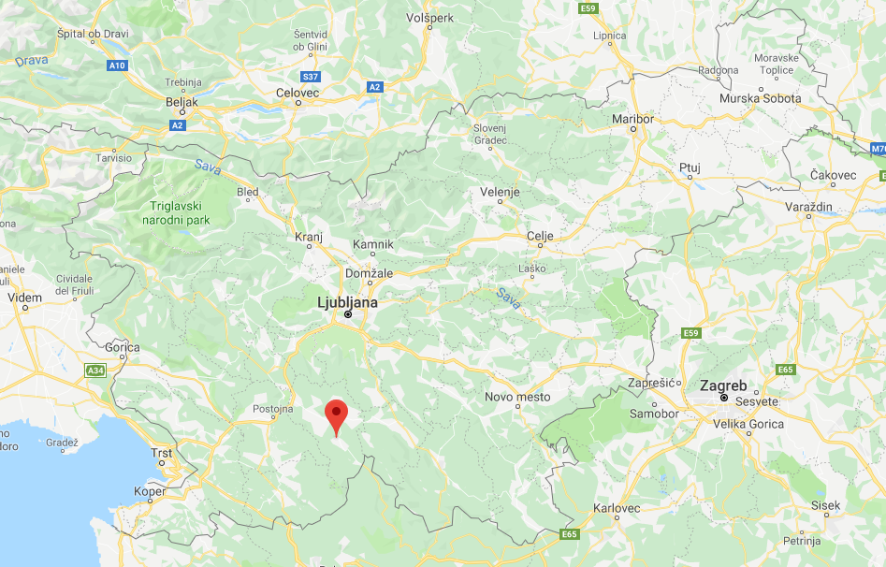
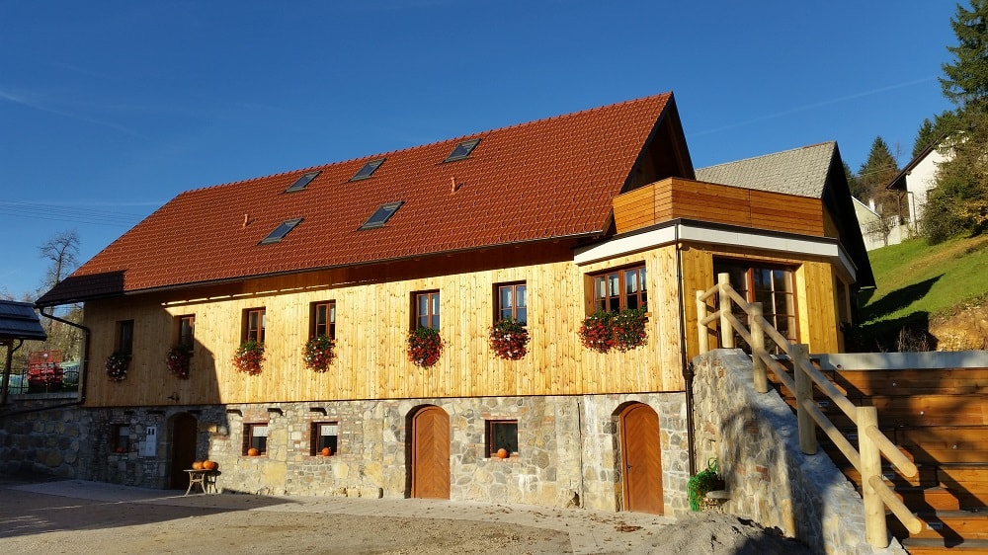

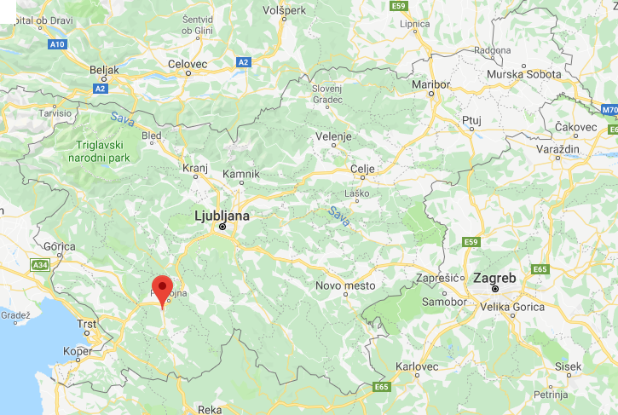
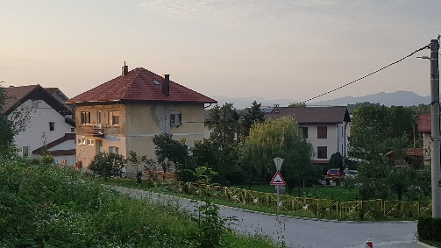 VENUE AND ACCOMMODATION – PRESTRANEK

Living in house with other volunteers, sharing room, bathroom and kitchen.
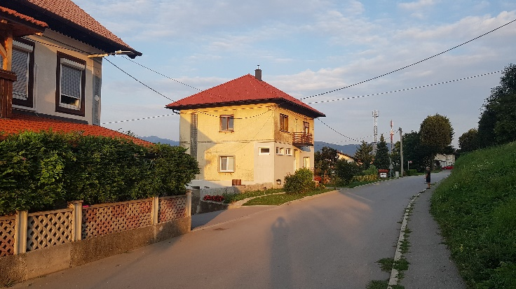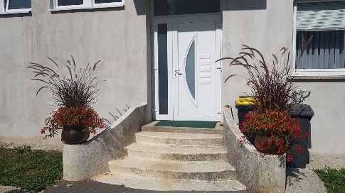

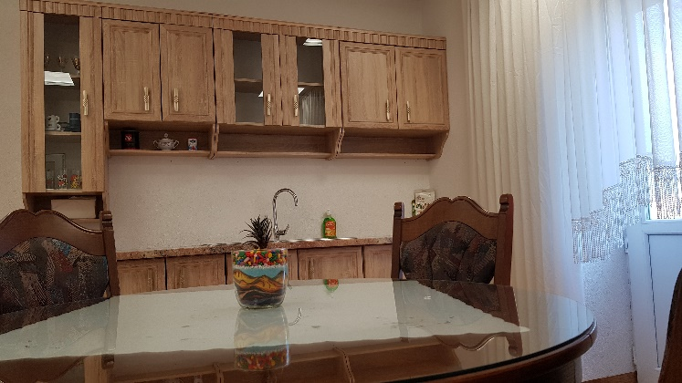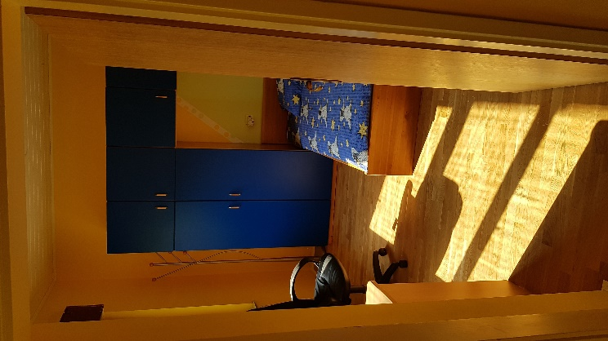
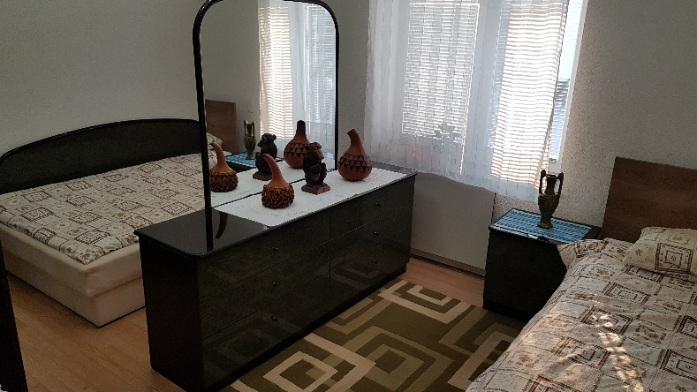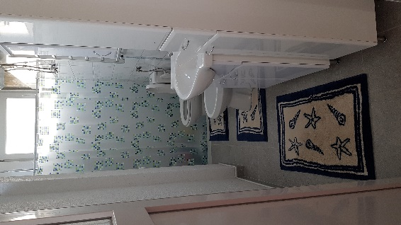
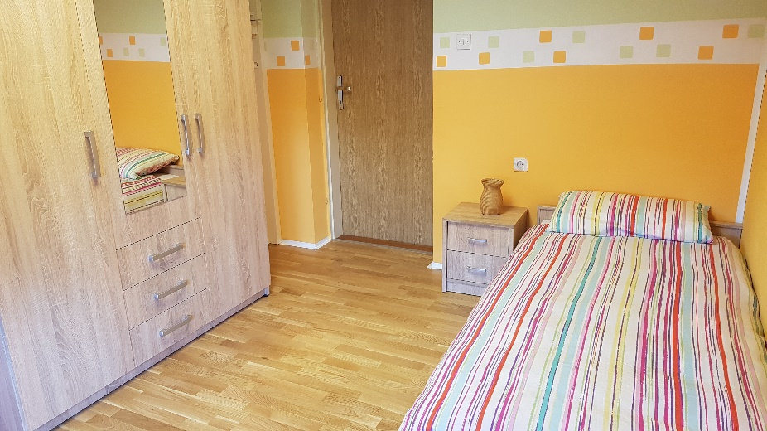

WORKING HOURS
Daily activities cover 30/36 hours per week.
Volunteers have 2 free days per week, normally Saturday and Sunday. The ESC volunteer has 2 extra days off per month.

POCKET and FOOD MONEY
The pocket money is calculated on the ESC - European Solidarity Corps programme, which amounts, in the case of Slovenia, to € 4 / daily. The food money volunteer will receive once per month in their account, at amount € 180/ month.

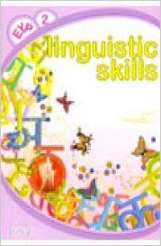 LANGUAGE SKILLS
Online linguistic assessment and language courses in Slovenian will be available via the Online Linguistic Support (OLS). The volunteer will also have the opportunity to practise additional anguages through community and learning activities promoted by the host organisation, which take place on a weekly basis.

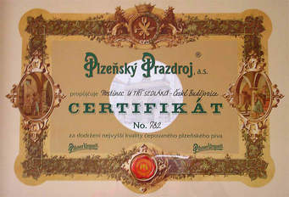 YOUTHPASS CERTIFICATE
All volunteers in the European Solidarity Corps programme are eligible for Youthpass Certificate,
a Europe-wide tool to document and recognise learning outcomes from youth work and solidarity activities. It is a part of the European Commission’s strategy to foster the recognition of non-formal
learning, putting policy into practice and practice into policy.

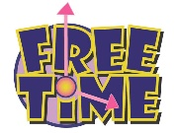 FREE TIME ACTIVITIES
Volunteers can also organise their own free time activities, and local staff will be very willing to offer assistance or suggestions.

HOW TO GET HERE
The journey from each volunteer’s home city to Postojna will be organised by the partner organisation in cooperation with hosting organisation.

LOCAL TRAINS: Prestranek regional train stop at Postojna train station (6,3 km / 12 min)

LOCAL / NATIONAL BUSES: Prestranek regional bus stop at Postojna bus station. From Postojna to Podcerkev is 31 km, one hour drive by bus.

CONTACT :
http://arsviva.si/

Dragana Kosić Petrović – coordinator
dragana@mcp.si
https://www.facebook.com/dragana.k.petrovic
+386 40 798 222

