Overseas Volunteers at Leonard Cheshire Disability
Seven Rivers
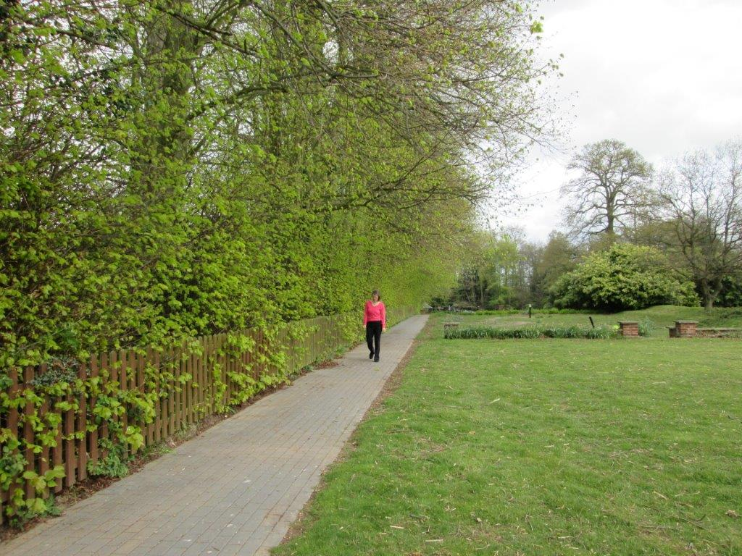
What is my role?
At Leonard Cheshire Disability, we value the role our Overseas Volunteers have in our services throughout the United Kingdom. Due to the length of the placements for overseas volunteers (12 months) volunteers have the opportunity to acquire a range of skills, improve their English, enjoy the best of British culture and life, and develop fulfilling working relationships with our residents, staff and local volunteers which often develop into long-term friendships.

Overseas volunteers help support our staff teams in providing an active, involving and stimulating environment for our residents. Through our overseas volunteers, disabled people in our care homes are able to access their local community services and social opportunities more easily and regularly, thus improving their independence and quality of life. This means that in their roles overseas volunteers are engaging in a wide range of activities both inside and outside the home.

Volunteers may be required to accompany residents on activity weekends and short holidays, as well as providing support to those service users who have regular work, education or volunteering commitments. Volunteers will support groups of people with art and craft, gardening, cooking, exercise and social clubs and outings. While it is a lot of fun going out with residents, it is also very challenging as volunteers experience first hand the issues faced by people with disabilities everyday.

Overseas volunteers will be expected to volunteer 35 hours within a week. They will be entitled to 2 days off. These may not necessarily be at the weekend or consecutive. There can be a greater requirement for volunteering at the weekends to attend sporting events and other activities.

What opportunities can I expect for training & skills development?
Thorough training on working with vulnerable adults is provided to all our volunteers, and Leonard Cheshire Disability staff helps volunteers during the induction process to understand each individual. Risk assessments ensure that volunteers are not asked to contribute outside of their capability or boundaries.

Volunteers acquire a range of knowledge, skills and experience including a greater understanding of the issues affecting disabled people. They gain improved interpersonal skills and the ability to interact with a wide range of people. There will also be an opportunity to learn about the wider activities of the charity, for example our campaigning/lobbying activities and fundraising events.

About Seven Rivers
Seven Rivers was opened by Leonard Cheshire in 1958 as the 6th home in our organisation. We are set in the Village of Great Bromley, Essex. The House is located 7 miles away from the nearest town of Colchester, which is a historic town whose most famous inhabitant was Queen Boudicca of the Icini.

Our Home is set over 2 levels with lift access to the upper floor, we have 29 residents, with a range of disabilities: most of them need the use of a wheelchair. All the land around the home is set to grass. This attracts wildlife and we have a lake were residents go fishing.

Great Bromley is a village were the main occupation is farming, but a lot of the villagers now commute to Colchester or London to work. This has left the village with very few facilities, a limited bus service runs every hour and the nearest public house is 2 miles away with the nearest local shop approximately 7 miles away. The main shopping area is therefore Colchester with a wide range of shops. We do have bikes available for Overseas Volunteers, and provide you have a current driving licence and meet all requirement you may be able to use one of the homes cars.

The village hall offers a small range of activities such as badminton club, carpet bowls, cricket club, woman institute, and a friendship club.
Within the home we offer for sale small toiletry items and chocolate.

Great Bromley is close to Suffolk were John Constable was born: he was famous for painting ‘The hay wain’ and occasionally a trip is organised to visit Dedham were John Constable lived, worked, and died.

Accommodation & Expectations
Volunteers’s accommodation is located on the top floor of Seven Rivers, the lift only takes you up so far then there are a few steps: this makes it unsuitable for wheelchair users or people who are visually impaired. We have 3 bedrooms: 1 with en-suite bathroom, and 2 with a shared bathroom next door. We usually host only 2 volunteers at the time. Between the bedrooms is a small lounge area with TV, DVD, Fridge and kettle. Volunteers are able to use the House washing machines to do their own laundry. WiFi does not connect to the volunteers rooms but we are able to offer a private space to enable them to do so.

Volunteers are expected to comply with Leonard Cheshire policy & procedures & codes of conduct. Failure to comply with this could result in the programme being terminated.
Volunteers are not to take part in activities that are staff tasks, they therefore will not be assisting with eating and drinking or taking part in personal care.

Behavior that causes concern as a result of excessive alcohol is not tolerated. The misuse of illegal substances will not be tolerated and will result in instant dismissal. Volunteers are expected to behave in a socially responsible way, and in consideration to fellow volunteers and residents.

This is a year-long placement and volunteers are expected to commit to the service for the whole duration of their project.

Volunteer Profile
At Leonard Cheshire Disability Seven Rivers we all enjoy meeting new people. And do not discriminate on the grounds of ethnic origin, religious beliefs, sexual orientation or political opinion. We are looking for enthusiastic people with a good sense of humour who enjoy working with people and working as part of a team.

We are interested in hosting EVS Volunteers who are keen to learn about disability issues and support. While any previous experience in disability support, healthcare or social work will be an asset, this is not essential. To ensure universal accessibility, we do not require volunteers to hold any specific qualifications or a certain educational level.

Some of our residents find it difficult to understand those with strong accents, so someone with good English skills and understanding would be desirable. This will also ensure that from a H&S perspective we can be confident that our volunteers follow all procedures in place for their own and our customers safety.

We offer full training for volunteers and support their learning experience. We know that skills can be acquired but real enthusiasm and passion are qualities that only people with a real interest in the project can bring. We develop the volunteer role by reviewing what the customers’ needs and aspirations are.

We ask that volunteers have interests, hobbies and skills that they are willing to share with customers. Interests that complement therapeutic activities: e.g. art, music, cooking, drama and sport, will be beneficial. This is particularly important as we expand the options customers have for activities and encourage them to try new things.

Activities
Seven Rivers is most of all a home, with its own community that allows people the freedom to live, work and give expression without fear.

EVS volunteers will support our staff teams in providing an active and stimulating environment for adults with learning and/or physical disabilities, which will ensure that they can fulfill their long-term personal goals in accordance with the person-centered plan. EVS volunteers will support disabled people at Sever Rivers to access their local community, its services and social opportunities, more easily and regularly; at the same time they will stimulate them to do activities, thus improving their confidence, independence and quality of life. We strongly believe in being a learning and mentoring service, and would like the opportunity to host people to allow them to develop new experiences within their lives.

Proposed activities:
The specific objectives for each future EVS projects will differ, the main aim of all projects is to empower and enable disabled people to access social and leisure activities in Great Bromley.

Typical tasks within Seven Rivers will vary depending on the specific need of residents and the volunteers’ skills and passions: they will include befriending, supporting people with social activities such as quiz and games, arts and crafts, cooking, garden projects, sports, reading a book in a 1 to 1 setting, supporting with events and fundraising activities, getting the people involved, running IT classes.

Specific areas we would like to develop:

- Re-introduce our residents vegetable garden
- To find new ways to raise funds
- To find new ways to help and challenge our residents

Contact details
Seven Rivers
Hall Road,
Great Bromley.
CO7 7TR

Volunteer co-ordinator:

Elizabeth Barrenger: Elizabeth.barrenger@leonardcheshire.org

