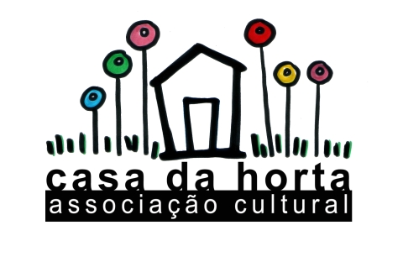
Applicant full name:

Casa da Horta Questionnaire

1. Why do you want to do a volunteering work at Casa da Horta?

2. What do you expect from this experience?

3. What skills/ideas/initiatives can you bring to Casa da Horta?

4. We are a non-hierarchical association that makes decisions through meetings, discussions and
reaching consensus. What do you think about this kind of organisation of work? Why?

5. Tasks division: in Casa da Horta everyone does a little bit of everything (cooking, events preparation, cleaning tasks, gardening and so on). How do you feel about this multi-task environment?

6. Please describe an enriching experience you’ve had (any kind, you choose :))

