CALL FOR PARTICIPANTS – Erasmus+ Mobility of Youth workers
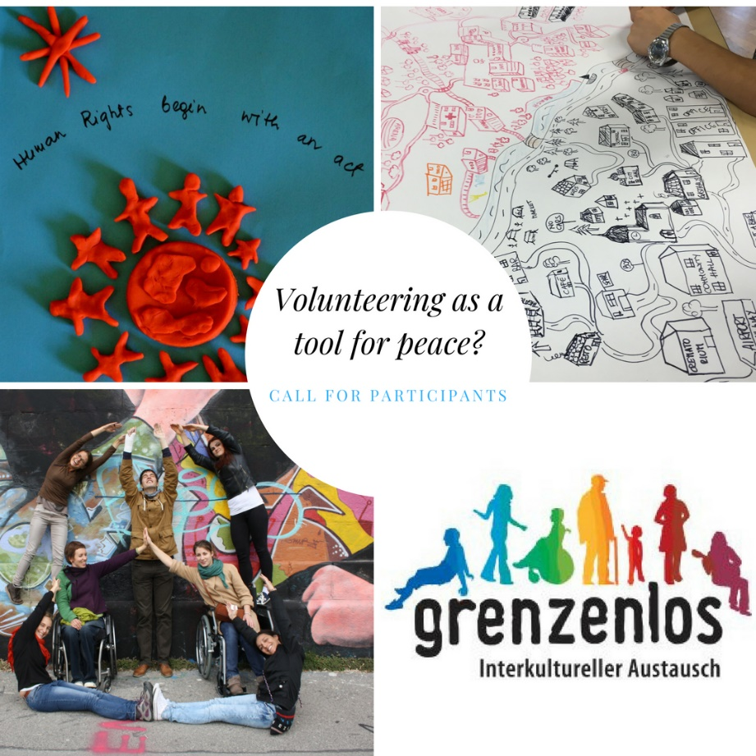
Venue: Vienna, Austria
Duration: 5 days 15.-19.10.2018 (excl. arrival and departure-day)

Background of the project

Grenzenlos is running international projects and exchanges since nearly 70 years. In the last years we dedicated our trainings to the topics of civil courage and human rights.
We define ourselves as a peace organisation and are an official peace messenger through our network ICYE (www.icye.org). That’s why we want to get to the core of our work. We’ve started to question ourselves if the tools we use are still leading to our aim and are still appropriate and useful for today`s challenges of the youth and societies we work with.

The Grenzenlos board of managers decided a theme for this and next year: We want to reflect on our starting point of volunteering exchanges “Peace Work”. That’s why we will also focus our seminars and trainings in 2018 and 2019 on Peace. Therefore we plan to start with organizing a 5-day seminar where we would like to exchange ideas and concepts with other youth workers and volunteer exchange organisations in order to use our capacities as peace messengers.

The seminar is part of a bigger strategy on promoting peace and the contribution of volunteering to it. Grenzenlos will apply for a serial of activities, f.i. we intend to apply for a training course for youth workers as a second step in 2019.

Aims and Objectives

To discover “What is peace?”
To Get inspired on how can we keep a peaceful society:
What can I do as an individual? What can youth organisations do?
To share best practices
To promote peace and fight against anti-hate speeches
To promote peace work within international volunteering projects
To have fruitful debates and learn about peace work among young people from all over Europe

Who can participate?

We are looking for participants who are active in your youth organization (volunteers, staff, mentors ...)
Note that all participants should

be 18+ (no upper age limit!)
Involved in the work of your organisation (as a volunteer and/or worker)
Able to attend the whole duration of the course
Able to work in English
Interested in peace work as such
Ready to pass the knowledge on

The main working language will be English.

We strongly encourage organisations to send participants with a physical disability to the training course. Participants with disabilities will not need to pay the participation fee!!!

Venue/Date

The training will take place in Vienna from the 15.-19.10.2018 (14.10. Arrival/20.10. Departure)
The venue is accessible for wheel chair user!

Application & financial support

Participation fee: 100 Euro

Participants with disabilities can participate free of charge!!!

The Financial support is sought within the Erasmus+ programme, Key Action 1.
Depending on the distance to Vienna you will receive a travel lump sum. For more details have a look at the Erasmus+ Users guide. Board and lodging will be covered by the Erasmus+ program

Deadline

Please make sure that we receive your interest latest till 1.9. 2018
If you need any assistance please contact us as soon as possible in order to clearify if we can cover the full costs. We are looking forward to receive your expressions of interest!
Sunny greetings from Vienna

Barbara Eglitis & Carlos Gauna for the Grenzenlos Team

The Training is open for EVERYONE also for participants with disabilities! Please encourage participants with disabilities to register for the Training! The fee for Participants with a disability is coverd by Grenzenlos!

