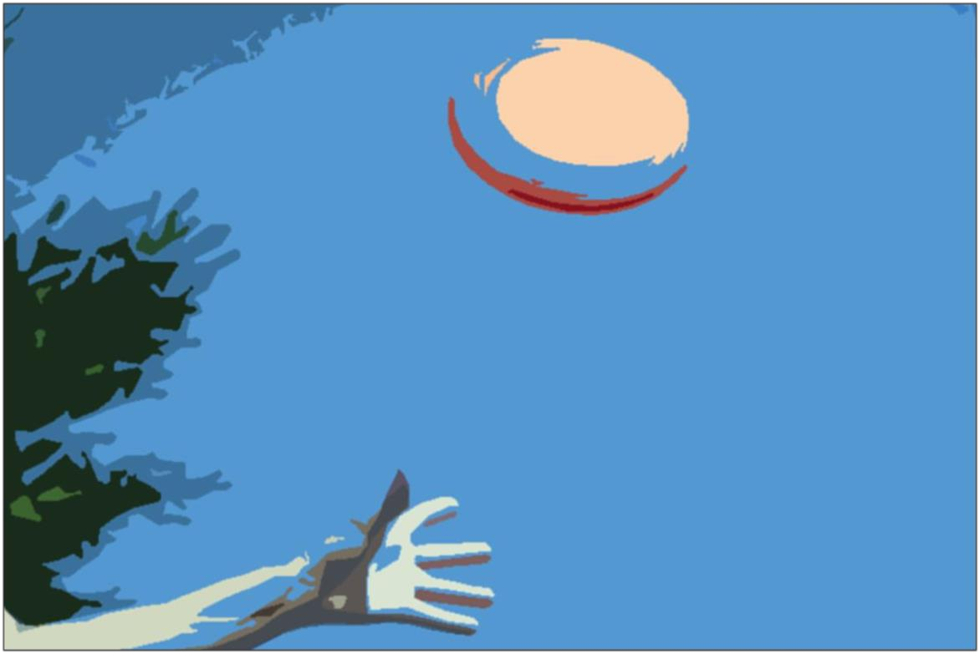

2018

Welcome to Lugo!

ASOCIACIÓN SOCIOEDUCATIVA EDUCERE

Visionars ON BOARD! M/S Lugo
18-6-2018

INDEX

This document contains:
- General information: Country/Region/City 2
- Climate 7
- Brief summarize of the Project and tasks… 8
- Accommodation / lodging……………………………… 8
- Rights and duties… 9
- Rules of hosting organization 11
- What to bring? List for participants 12
- Emergency numbers and addresses… 12
- First words / sentences in Spanish 13

- GENERAL INFORMATION: Country/Region/City

Spain is a sovereign country, member of the European Union from 1986, constituted in social and democratic state of right, whose form of government is the parliamentary monarchy. Its territory, with capital in Madrid, is organized in seventeen autonomous communities and two autonomous cities, these formed, in turn, by fifty provinces.
It has an area of 505.370 km², being the fourth largest country on the continent, after Russia, Ukraine and France, with an average altitude of 650 meters above sea level, it is one of the most mountainous countries in Europe.
Its population is 46.468.102 inhabitants (2016). The peninsular territory shares land borders with France and Andorra to the north, Portugal to the west and the British territory of Gibraltar to the south. In its African territories, it shares land and sea borders with Morocco. Share with France the sovereignty over the island of the Faisanes at the mouth of the river Bidasoa and the five Pyrenean fields.
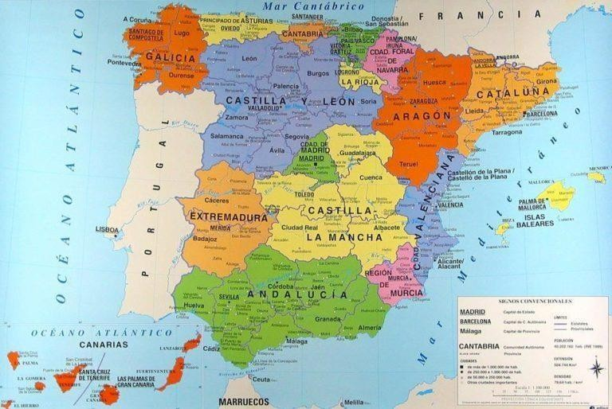

The Spanish culture has its roots in the influences that different peoples have left after their passage through the peninsula throughout the centuries. Although there is a cultural heritage common to all Spaniards, the marked singularity of its regions has given rise to diverse cultural manifestations throughout its geography. These manifestations have been reflected in all fields: art, traditions, literature, languages and dialects, music, gastronomy, etc.

The siesta is a tradition that is receding, especially in the cities. The normal rhythm of the day in Spain usually continues divided into two periods, morning and afternoon, with a pause of two or three hours during the meal. A walk in the late afternoon is a widespread custom in many places.
Dinner time, as in some regions of southern Italy, is the latest in Europe, usually around 9/10 p.m.
The fun is characterized to take place at night, even until the wee hours of the morning. In the center and south of the peninsula, the summer heat has boosted this phenomenon. Nightlife starts late. Many clubs, even in relatively small cities, open at midnight and do not close until dawn.
In relation to food, geography, culture and climate have created a very varied cuisine in recipes and culinary styles. The different civilizations that have passed through the peninsula have also left their imprint, which has reached our days. Part of that influence is due to Jewish and Moorish tradition.
Fish is an important part of the Spanish diet. Meat, however, is usually more common in the interior. There is an obligation to mention of olive oil, whose tradition is millennial in Mediterranean cuisine.
A brief list of typical and popular dishes and drinks could be as follows:

Rice pudding | Paella | Wrinkled potatoes | Cheeses
Cod | Fabada | Bleeding | Omelette
Botillo | Gazpacho | Bread with tomato | Tapas
Callos | Horchata | Migas | Cider
Spicy Sausage | Ham | Blood sausage | Wines from Spain as Rioja, Ribera del Duero, Alvariño…

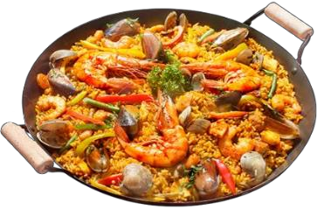
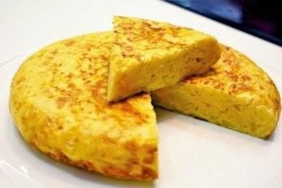
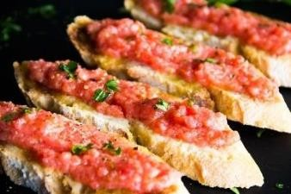

Galicia is a Spanish autonomous community, considered historical nationality according to its Statute of Autonomy. It is located in the northwest of the Iberian Peninsula and formed by the provinces of La Coruña, Lugo, Orense and Pontevedra, which are composed of 313 municipalities, grouped in 53 districts. The capital is the city of Santiago de Compostela, while Vigo is the most populous municipality.

Geographically, it limits to the north with the Cantabrian Sea; to the south, with Portugal; to the west, with the Atlantic Ocean; and to the east, with Asturias and Castilla y Leon (provinces of Zamora and Leon). In addition to the mainland, it includes the archipelagos of the Cies, Ons and Sálvora islands, as well as the islands of Cortegada, Arosa, Sisargas or Malveiras and other smaller islands.

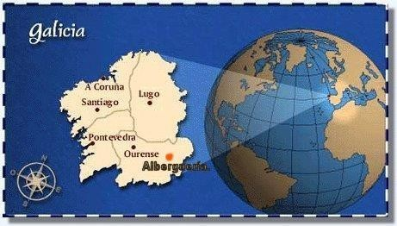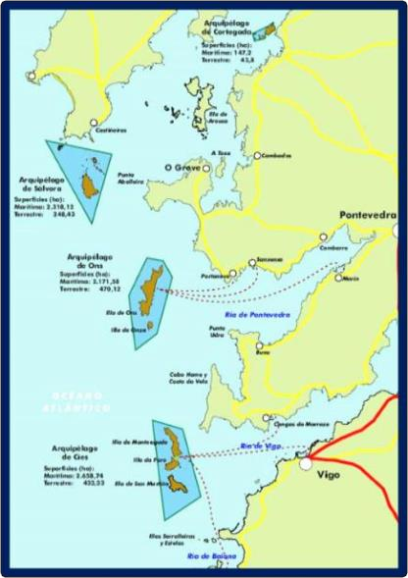

Galicia has 2.726.291 inhabitants (2015), with a demographic distribution that agglomerates the majority of the population in the coastal strips between Ferrol and La Coruña, in the northwest, and between Villagarcía, Pontevedra and Vigo in the southwest.
The culture of Galicia has many affinities with those of the other towns on the Cantabrian coast and, by extension, the rest of Spain and Europe. One of its most defining aspects is the Galician language, which has many ties with Portuguese and is spoken by approximately 2,587,400 speakers.
At present we have a rich and lively culture, which starts with tradition, but has incorporated contemporary languages. The fact of being the end of a Path "Saint James Way", which has culturally vertebrate Europe, has facilitated the penetration of the currents of European art and thought throughout the Middle Ages. Besides, the emigration to America had a great influence.
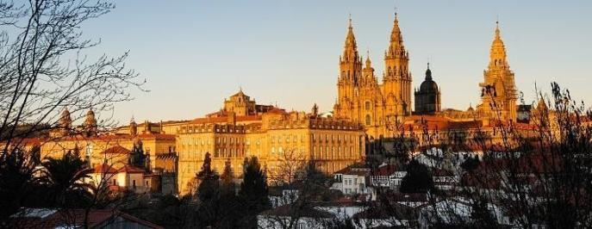
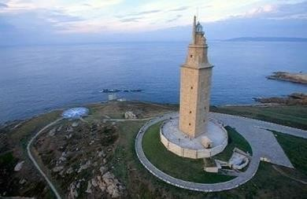

The Galician cultural heritage is characterized by its richness, diversity and geographical extension, as well as by its connection to the surrounding landscape. The megalithic monuments abound - rock engravings, or castres, and there are numerous Roman remains, including the Muralla de Lugo or the Tower of Hercules of A Coruña, declared a World Heritage Site by UNESCO. But if something turns it into a referent European are the multiple arteries of the road that leads to Santiago de Compostela, a city recognized by UNESCO as World Cultural Heritage.
At the end of the Jacobean route is the cathedral of Santiago de Compostela, symbol of Galicia for its patrimonial value, for its historical importance in shaping the European identity itself.
With its more than 30,000 population centers, the Galician landscape is deeply humanized. The architectural heritage is dominated by religious buildings in granite. Within the ethnographic patrimony stand out, by value and number, the “hórreos” - and the stone crosses or “cruceiros”.
In relation with Galician food, it can be mentioned its traditional hospitality, being usual that in case of going to eat at the house of an old person and of a rural environment, it is ostentatious Its pantry, being considered of good education to offer and insist the guest so that it does not have repair to eat in abundance, being considered a certain discourtesy not to accept or to believe it sign of weakness.
In Galician society, in spite of the modern globalized habits, it is very valued to eat in company, being habitual to see how several friends meet to share table and tablecloth, even in the daily working days. The recess in the day is made with food and usually prolonged more than in other places.
The fundamental characteristic of Galician gastronomy is the high quality of its raw materials, both in meat of all kinds (mainly cow, pigs and chicken), as products of the sea (Galicia has a long tradition of seafood and the use of all types of marine resources), as well as in derivatives (very important dairy production, although harmed by incorporation into the EEC) and agricultural products (varied cereal and horticultural production).

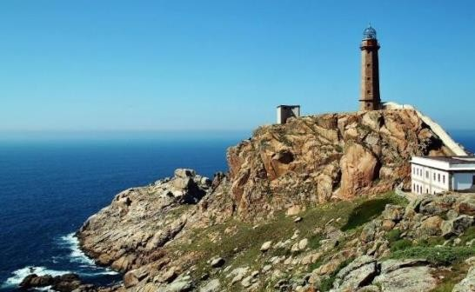
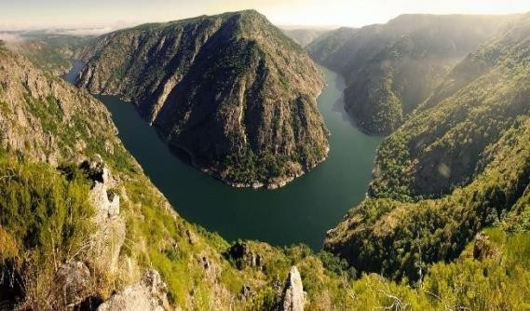

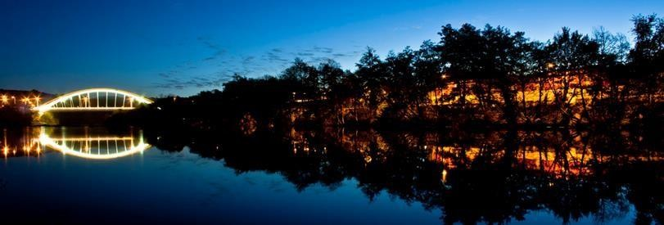
Lugo, host city of the project, is bordered by the Cantabrican Sea from the north, the cities of A Coruña and Pontevedra from the west, the province of Ourense from the south and Principality of Asturias with the province of León from the east. Geographically, the city is located on a hill, in a region of rounded and not very high mountains, surrounded by the river of Miño.

The city has roman origins and it was founded 25. A.C., being the oldest city of Galicia. It was built near to a fort in the Roman and it maintained its very own and unique Roman wall which was declared a World Heritage Site by Unesco in the year of 2000. Till today the Roman wall is one of the most important symbols of Lugo.
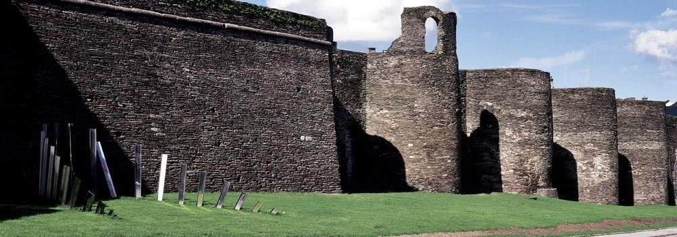

Lugo is a commercial city and services, and its university is specialized in the sciences of agriculture (e.g. engineering and veterinary). They emphasize its popular festivals like
‘’Arde Lucus’’, which recalls the Roman age and the past of the city, and ‘’San Froilán’’
that attracts more than a million visitors to the city every year.
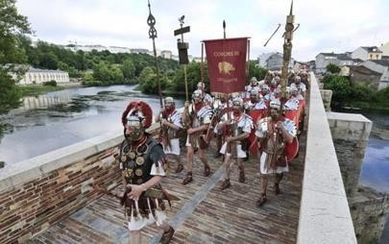
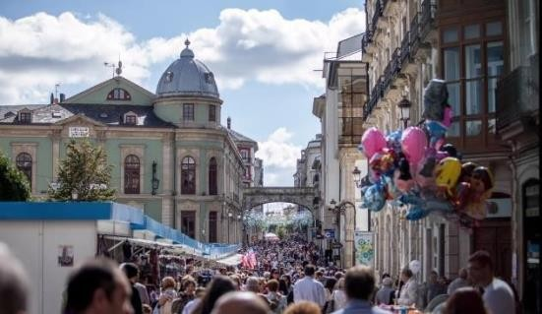

On the other hand, the city holds a lot of beautiful squares, peaceful parks and other landscape areas with outstanding sights such as the Cathedral, the Archbishop Palace and City Hall.
Leisure and free time activities in Lugo are variable. There are many different sports field to access (e.g. football, basketball), a skatepark in the park of Frigsa, river and swiming pools to swin and also very rich cultural activities with different programs (e.g. dance showcases, different concerts) in Círculo de las Artes or live concerts in Clavicémbalo club.
Besides, most of the markets and shops in Lugo are closed on Sundays. Regular hours of supermarkets and the shops are from 9 / 10 am - 14 pm and from 16 pm - 21pm.
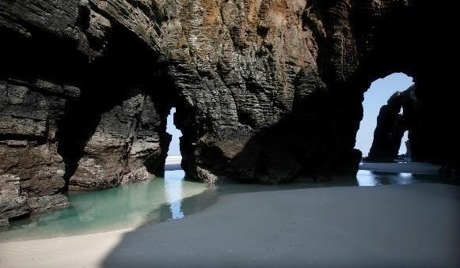
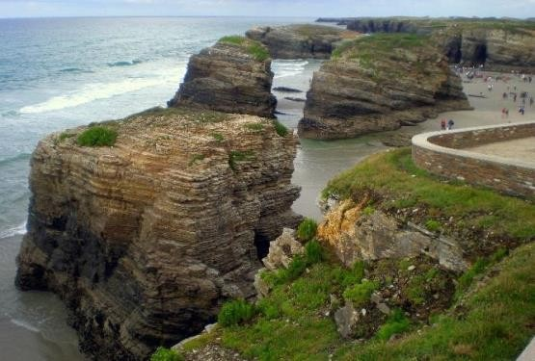
The main towns, apart of the capital (Lugo), are Monforte, Viveiro, Ribadeo, Villalba, Sarria, Burela, Chantada and Mondoñedo. In the north of the province of Lugo are many beaches, viewpoints and lighthouses. It must be destacated one beach called "The Cathedrals" which is considered as one of the most spectacular beaches of the world. It is called this way by the set of cliffs, some with more than 32 meters of height, that carved by the wind and the sea, form arcs and spectacular vaults leaving a wonderful landscape.

- CLIMATE:

The climate is continental oceanic, with cold winters and mild summers. The average annual of temperature is 11.5°C and rainfall is abundant (over 1000 mm per year). Because of its distance from the Atlantic, this level of precipitation may be considered low compared to regions such Santiago de Compostela or A Coruña.
A web page to look for the weather in Galicia is: http://www.meteogalicia.es/

- BRIEF SUMMARIZE OF THE PROJECT AND TASKS:

The project is aimed primarily at local youth, but our goal is to involve the entire community regardless of age, gender, etc. The central theme of this proposal revolves around the promotion of healthy living habits, offering new alternatives for leisure time to the inhabitants of the city of Lugo.
Volunteers will help with the promotion of the new sport introduced in the city, Disc Golf. We will organize different public events for it. Also they will help us to promote healthy living habits and EVS in our city.
We will encourage them also to share their own proposals (related with the promotion of healthy lifestyles in the host community), trying to carry out as most of proposals as be possible for us during the development of activities.
In addition to this, volunteers will have Spanish lessons twice a week, two hours a day.
We will organize the On Arrival Training for each group, the first three days of the Activity, and other activities related with the interculturality, the Knowledge of the hosting culture/country, the improvement of the social abilities, workshops, among others.

- ACCOMMODATION / LODGING

Volunteers will live together in a flat. The flat is provided with internet,
2 bathrooms, 4 rooms, 1 living room, equiped kitchen (with microwave, oven, kitchen, fridge, cooking utensils, etc.), washing machine, among others, safe and adequate to the conditions of the country and the region.
Participants will have to share room with other volunteers. The flat counts with: 3 double rooms and 1 single.

Google maps:
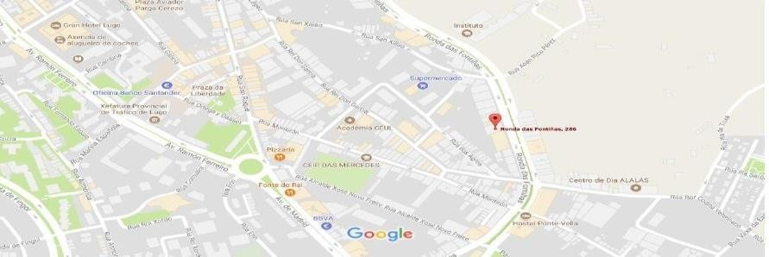

https://www.google.es/maps/place/Ronda+das+Fonti%C3%B1as,+286,+27002+Lugo/@43.0031003,- 7.548027,17z/data=!3m1!4b1!4m5!3m4!1s0xd31cc1ff984cfdf:0x19eb6e7ae5776af7!8m2!3d43.0031003!4d- 7.5458383

IMPORTANT CONTACTS FOR VOLUNTEERS:

CONTACT DETAILS

- Mentor-Social Worker: Aessatou Gassama; +33686031530; aessagassama@gmail.com

- Mentor-Phycologist: Aldara Pérez; +34 659017229; aldarapg23@gmail.com

- Spanish teacher: Teba Villar; +34 606 344 529; tebavr@gmail.com

- Tutor/P.Coordinater: Eva Carricoba; +34 650212426; aseducere.info@gmail.com

- RIGHTS AND DUTIES:

  - Volunteers will be the resposables of preparing meals and the cleaning house maintenance, always supported by their mentor. Besides, they will share room with other volunteer.

  - Volunteers will have 3 days of holidays marked in one of the two last weeks of the activity-project.

  - The financial support in form of pocket money for the mobility period has a maximum amount of 168 EUR. The volunteer shall receive the pocket money in six payments of 28€ each, by cash, after signing a receipt of this amount of money to the host organisation. First payment will be at the start of the Activity and at the start of each week respectively.

  - Participants shall receive money for food each week. It will be paid by the host organisation, once a week. Meals will be organised, in the sense that the group will cook and eat together during the week of work. The most essential things, volunteers will have at home when they arrive (detergent, cleaning products, milk, oil, some vegetables and fruits, among others) and they will have to manage a fixed budget to buy other more specifics with the support of the mentor assigned. This money will be given to the group of volunteers - all the amount together- once a week, after signing a receipt of this amount of money to the host organisation.

  - Volunteers will have an assigned mentor and a tutor who will support them and their learning process during the whole activity. The mentor will live with the group of volunteers in the same flat.

  - The activity will be recognizing with YouthPass Certificate. Volunteers will receive this Certificate after completing the Project successfully.

  - Volunteers will receive a basic Spanish language course, during one hour and half, twice a week, by a teacher.
------------------------------------------------

- Participants must respect the rules established by the Host Organization, related with the safety, the use of the facilities, materials, among other.

- Carry out voluntary action with equality and justice, without discrimination or treatment based on sex, religion, social status or political creed with respect to other participants or people involved in the activity.

- Volunteers shall keep and give the invoices, receipts etc., provided by the supermarkets and shops, to the host organisation, helping us to justify the food costs to the Spanish NA.

- Participants shall complete the on-line EU Survey at the lastest 30 days after the end of the mobility period.

- Everyone in the house will have a set of keys, with a key to the front door and another to the apartment. Participants must take care with the keys. In case that you lose them, you must notify it immediately to a responsible of the host organization to maintain the safety of everyone in the house. At the end of the project, volunteers must deliver the keys to a responsible of the host organization.

- Participants should be punctual at the start of daily activities. Volunteers must try to respect the established timetable.

- Rooms will be used by their occupants and each person must keep his/her room clean, linens must be changed during the month activity and washed!

  - RULES OF HOSTING ORGANIZATION

DRUGS
The home and the workplace should be free of alcohol, tobacco and all kind of drugs.
Legislation in Spain prohibits the sale of alcohol and tobacco under 18 years old. It´s not permitted to smoke in public places, transport, bars, restaurants, etc.
People with 18 year old or older, can drink alcohol in their free time, outside of home.
Please, you could make use of it but you must not abuse of it!
Illegal drugs are reason of immediate expulsion of the project. In this case, volunteer will have to pay all cost of travel outside of within any responsibility of the hosting and sending organisations.

GUEST AT HOME
It is not allow external people to the host organization or the volunteers at home. Particular or special cases must be consulted with a responsible of the host organization.

SLEEPOVERS / GOING OUT
People with 18 years old or older can sleep out of the house, but always must to consult it with a responsible of the host organization. We have to know always where you are; also when you go out, if you are going to another village you must notify it before to the host organization for security reasons.

Warnings!! ILLNESS
If you're sick, please, notify it immediately to a responsible of the host organization, so we can help you¡

  - WHAT TO BRING? LIST FOR PARTICIPANTS

- Working clothes and shoes (clothes/shoes you don´t mind to get dirty – warm clothes).
- Comfortable shoes or gym shoes / sportswear.
- A backpack.
- Swimming clothes, flips flops and swimming cap.
- Toiletries: toothbrush and toothpaste, shampoo and SOAP/shower gel, towel(s) for showering, etc.
- Rain coat.

- A cap.
- Personal medicines.
(*) It is not recommended to carry valuables.
(*) Please bring as well some materials for the international evening! (music, traditional
costumes, food, photos, touristic information, flags…).
(*) Don't forget the European Health Insurance Card!

  - EMERGENCY NUMBERS:

[Prefix in Spain is 0034, you have to press it before of the telephone number] From a mobile phone for any emergency: 112
National Police: 091 / Local Police: 092

Hospital: 65 / +34 982296900

Ambulance: 061

Firemen: +34 982212000

  - FIRST WORDS/SENTENCES IN SPANISH

- Hola - Bienvenido / Hello – Welcome

- Encantado de conocerte / Nice to meet you

- ¿Cuántos años tienes? Tengo … años / How old are you? I am…years old.

- ¿Cómo te llamas? Me llamo… / What´s your name? My name is...

- ¿De dónde eres? Soy de… / Where are you from? I am
from...
(Austria, Inglaterra - Reino Unido, Hungría, Portugal, Finlandia/ Austria, England - United Kingdom, Hungary, Portugal, Finland)

- ¿Cómo estás? Bien/Regular/Mal / How are you? Good/So So /Bad

- No entiendo, ¿podrías repetir, por favor? / I don´t understand, could you repeat, please?

- Si, No, Gracias / Yes, No, Thank you!

