Host organization‘s name: | “Tremtiniu namai” - Special social care home in Lithuania for elderly people.
Location: | Vilnius – capital of Lithuania
Organization number in EVS database: | 2015-1-LT02-KA110-003924
Organization website: | http://www.tremtiniunamai.lt/
Coordinating organisation‘s name: | Social action (https://www.facebook.com/socialinis.veiksmas/?fref=ts)
Contacts: | evs.action@gmail.com (Greta)
We need: | 1 volunteer
Period: | From 1 of September 2018 till 1 of August 2019 (11 months).

About the organization | Special social care home "Tremtinių namai" is a modern institution the purpose of which is to assure the long-term social care of fully or partially dependent elderly people and to ensure secure and dignified aging. Preference to be accommodated is given to the exiles. Exiles are Lithuanians who were forcefully repatriated to labour camps and Gulags (prison camps) in Siberia by Soviet government. At the moment we have 80 people, aged 66-100. "Tremtinių namai" is located in Vilnius city in a peaceful place surrounded by a beautiful forest and the river Neris, you can reach it with a public transport. "Tremtiniu Namai" maintains an active bond with the local community: with a centre for Art and Education as well as with the people living in the surrounding area.  Our target groups are elderly with dementia and elderly who have physical disabilities. We have special daily activities for elderly with dementia such as listening to the music from their past, watching funny movies, reading out loud poetry, playing dominoes, singing old folk songs, putting a puzzle together, colouring pictures, exercising. Physiotherapist organizes the daily physiotherapy exercises and North Walking activity. Social workers offer other different activities for elderly without dementia too: participating in our care house Choir activity, Literacy and Classical music club. We often attain professional musicians, actors, poets, folk artists wishing to perform at our home.
The main tasks for the volunteer: | The volunteers will be given the opportunity to learn about the specifications of the work with elderly people. The main role of the volunteers will be an assistance for the elderly who have dementia and/or physical disabilities. They will improve communication, social skills as well as they will become better at understanding gestures and facial expressions, identifying and recognizing the feelings of others, demonstrating empathy, decoding body language, determining appropriate behaviour for different social situations. They will learn how to bond and react in an appropriate way to the need of a disabled person in spite of the verbal barrier.  Possible activities for the volunteers: to help a client with personal hygiene (such as washing a client's face, helping to brush teeth), to go for a walk with a client (if a client has limited mobility - organise walk with a wheelchair), to help a client to dress and undress, to assist a client with eating, drinking, to help a social worker to organise an everyday activities, to help a social worker to organise celebrations, events, to help physiotherapist to organize the North Walking activity, to help physiotherapist to organize the physiotherapy exercises
The profiles of volunteer: | Basic requirements - respect for the person, self-motivation in work with retired people, willingness to develop a bond in spite of a verbal barrier, patience, equal attentiveness towards each and every one, initiative (willingness to do something, bringing up new ideas), positive attitude towards the work, concentration on the process rather than the result, ability to do things slow, working according to the persons timing, team working skills, ability to withstand smells and physiological fluids.
Impressions of EVS volunteer Stefano from Italy: | Dear new volunteer,  In Tremtinių namai all the activities revolve around the lives of our guests, and so will be your tasks.  First, you would contribute at serving breakfast and lunch in some of the rooms. Some of the seniors for several medical reasons are not able to eat by themselves. You would be required to help one person with the feeding, who would be the same every day, since connection and routine are important factors in these people’s lives.  Every day focuses mainly on two parts: sport activities and rotating daily activities. Your role is to help the social workers during these activities and you will be assigned to a group of people that you will invite to such activities. Some of them must just be informed about the time and place, since they are completely autonomous; others need to be assisted and carried with a wheelchair. This preparation to the activities sometimes can require a lot of time since obviously it is impossible to take more than one person at the same time.  The sport activities comprise a north walking group on certain days (when the weather allows it) and physical exercises in the chapel/auditorium. The first group is highly independent, while the exercises are mostly addressed to a special group.  The rotating daily activities include painting, handwork, music group, bingo and something that you can propose and/or lead by yourself with the assistance of a social worker. For instance, I teach my native language one day per week.  Sometimes there might be events hosted at Tremtinių namai, in that case the activities are suspended or modified. Such events might include a particular celebration, or most likely the visit of other volunteers (from schools, NGOs, etc.) or choirs and musicians. Seldom you may join some of our guests on an event taking place outside the facility, such as a museum, or following our elderly choir for a performance.  Try not to be stuck in the schedule of the daily routine, and find some free time to spend with some of the old people, whether taking a coffee or playing checkers with them. If by any chance, you will skip a day of work for holidays or just for a cold, everybody will terribly miss you and ask for you. Take into account that many of the seniors will emotionally adopt you as a grandchild.  The atmosphere is informal as in a big family, but the rhythm of work can be occasionally as demanding as in a hospital. The job requires empathy, responsibility, gentleness and a lot of patience. Do not be scared by the language barrier if you do not speak either Lithuanian or Russian: most of the times nonverbal language is what makes the difference. The staff is amazing and you will find support whenever needed as well as constant feedback.  Hoping to see you next year at Tremtinių namai.  Sincerely.  Stefano

PHOTOS YOU CAN SEE BELOW:

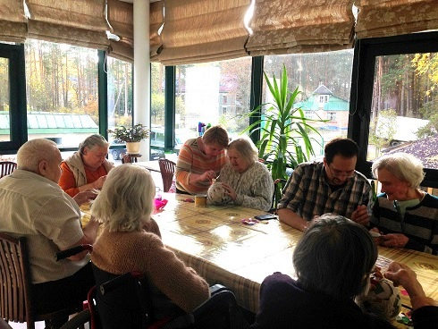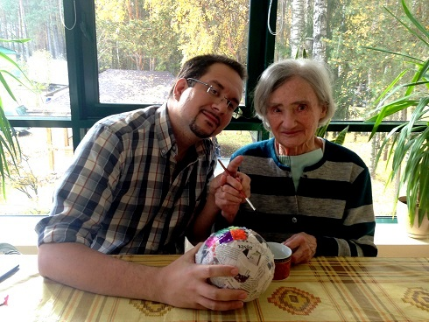
Stefano in his Host organization

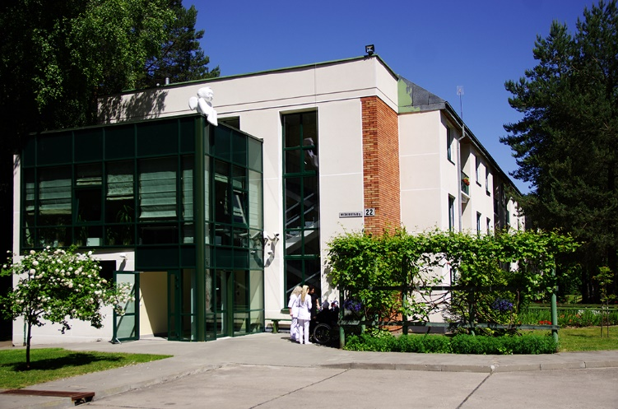
Tremtiniu namai organization
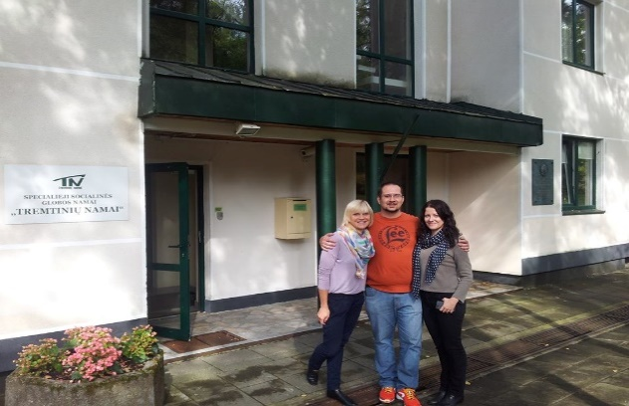 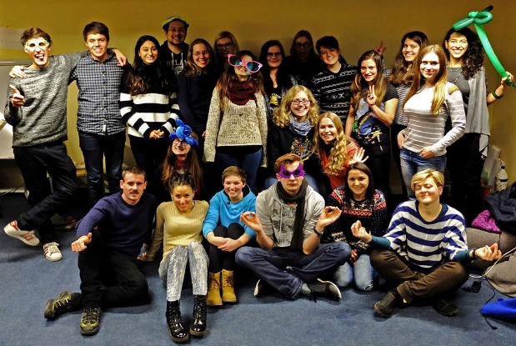 Stefano with his mentor and tutor Stefano with all the group of EVS volunteers

